ROUND VALLEY INDIAN HOUSING AUTHORITY
REQUEST FOR COMPETITIVE PROPOSALS
INSPECTOR SERVICES
COVELO CALIFORNIA

DATE: JANAURY 08, 2026
PRICE QUOTES DUE BY: FEBRUARY 08, 2026
TO: Prospective Offerors
SUBJECT: Request for Competitive Proposals

The Round Valley Indian Housing Authority, the tribally designated housing entity for the Round Valley Indian Tribes, will be constructing single-family homes. RVIHA is requesting experienced architect firms to submit a competitive proposal for development of single-family homes.
The inspector services shall include the following major tasks:
Vertical Assignment: Inspect various types of vertical construction projects including buildings, parks, water/wastewater plants, and appurtenances for compliance with contract documents (plans technical specifications, special provisions, ect.), applicable codes (including building, electrical, plumbing, mechanical, fire), and/or zoning requirements.
Proposals submitted in response to this Request for Competitive Proposal will be received at the following address until 4:30 Pacific Time, on February 08, 2026.
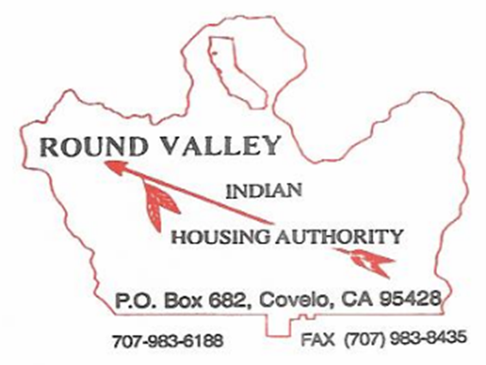
For more information please contact:
Lewis “Bill” Whipple, Executive Director
Round Valley Indian Housing Authority
P.O. Box 682
115B Concow Blvd.
Covelo, CA. 95428
(707) 983-6188 x 25

