ROUND VALLEY INDIAN HOUSING AUTHORITY
REQUEST FOR COMPETITIVE PROPOSALS
ARCHITECTURAL SERVICES
COVELO CALIFORNIA

DATE: January 08, 2026
PRICE QUOTES DUE BY: February 08, 2026
TO: Prospective Offerors
SUBJECT: Request for Competitive Proposals

The Round Valley Indian Housing Authority, the tribally designated housing entity for the Round Valley Indian Tribes, will be constructing a housing subdivision for single-family homes. RVIHA is requesting experienced architect firms to submit a competitive proposal for development of a housing subdivision of single-family homes.
The architect services shall include the following major tasks:
1) Preliminary Design
2) Design
3) Construction Documents
Proposals submitted in response to this Request for Competitive Proposal will be received at the following address until 4:30 Pacific Time, on February 08, 2026.
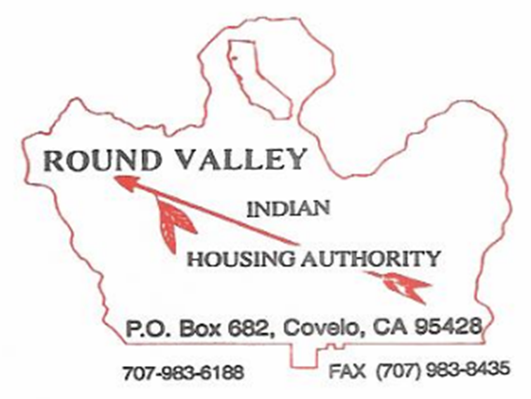
For more information please contact:
Lewis “Bill” Whipple, Executive Director
Round Valley Indian Housing Authority
P.O. Box 682
115B Concow Blvd.
Covelo, CA. 95428
(707) 983-6188 x 25

